**Python Programming Task 1**

1. 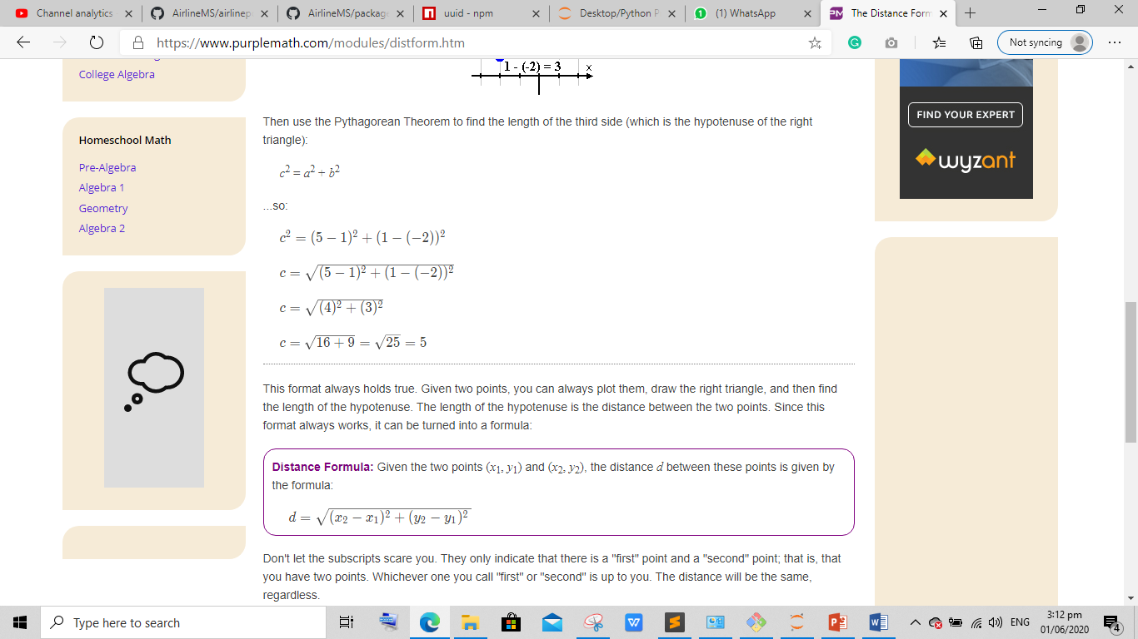

Input : x1 , x2 ,y1 , y2 from user and calculate value of d (hint: use math library for square root)

1. 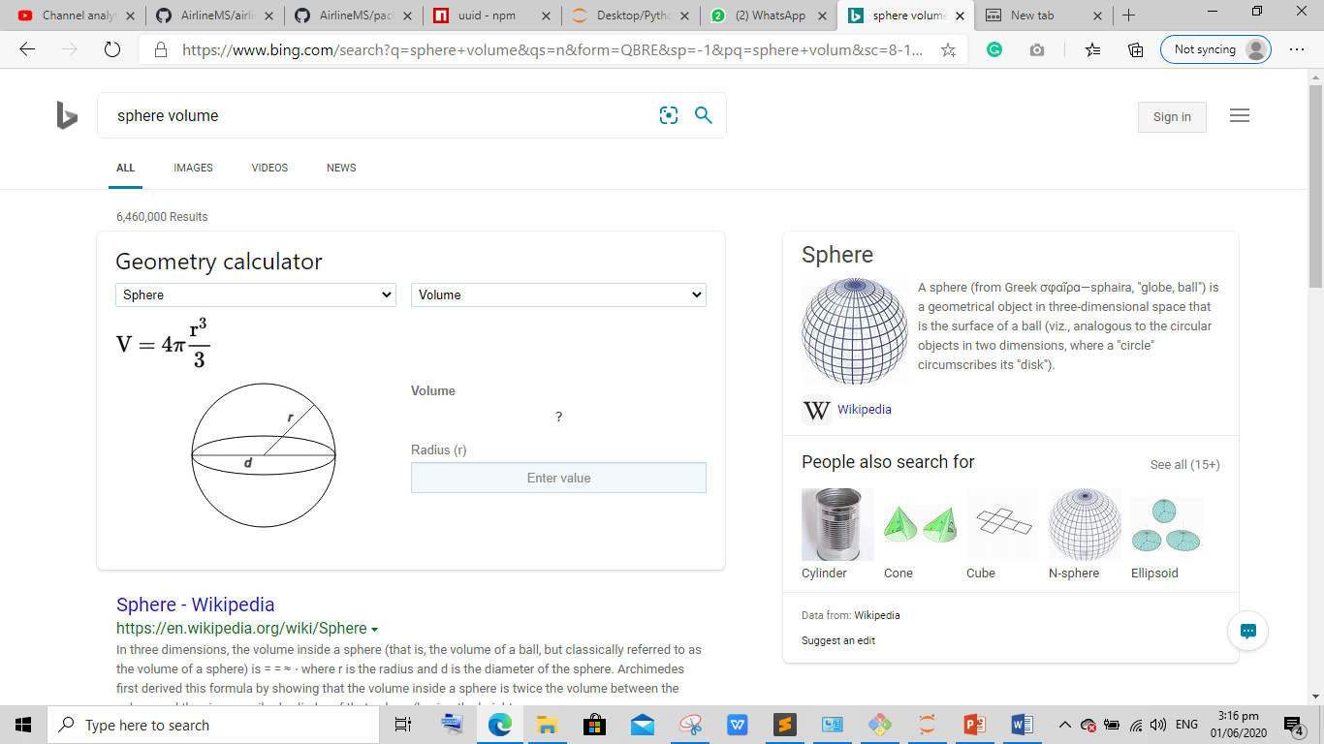

Input : r and calculate value of v (hint: use math library for the value of pi)

1. Name : Zain Zulfiqar

Age : 20

Height : 5.9

Hobbies : Cricket , Programming , Table Tennis

Print above statement using single print() function . You can replace above values with your attributes

Hint(use “\n” in print statement)

1. Permutation Formula : npk = n! / (n-k) !

Input : n , k

Hint( To calculate ! use math library)

1. Combination Formula : n! / (n-r)! * r!

Input : n, r

Hint (Same as above)

1. Taking three integer input from user and check three of them are equal or not
2. Name: Zain Age: 20 Height: 5.9

Print above statement from single print statement. Donot use space to seprate these values

Hint (Use “\t” in print statement).

Best of luck